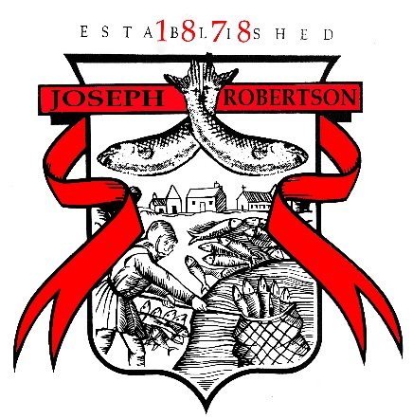

JOB DESCRIPTION

Job Title: General Operative

Reporting to: Team Leader

Reporting in: N/A

Cover when Required: Team Leader

Principle Objectives: The General Operative will alongside their team provide effective, timely and efficient manufacturing practice throughout all departments within the factory.

Main Responsibilities:
General Duties
- Making boxes
- Packing into boxes
- Building pallets
- Weighing and mixing to recipes
- Feeding fish at the front of line
- Cleaning
- Completing paperwork
- Operating a ‘tidy as you go’ policy
- Being responsible for quality of the product
- Highlighting any problems with the product

Health, Safety and Hygiene
- The assigned production area is kept clean & tidy
- Ability to demonstrate basic food handling practices
- Operatives conform to company rules and regulations

Equipment
- Inform direct Managers of any machinery problems

General
- Holiday and sickness cover as directed by Line Manager
- Any reasonable duties requested by the Company within the perimeter of the Company Policy and Procedure and Health and Safety manual.

I certify that although the above is not exhaustive, the information contained within the Job Description is consistent and reflects my current role.

Employee Name |  | Manager Name
Signature |  | Signature
Date |  | Date

